6_SS_Internet Research & Country Database
Class Periods: 2
Software: MS Access
Technology TEKS: 7C, 8E, 10B
Subject Area TEKS: 6.3A, 6.3C, 6.21A, 6.21C

Brief Description: Students in sixth grade history classes will use research skills to collect information on selected countries in _____________. (Teachers may choose countries that are presently being studied.) After collecting the information, students will use the data to create a database. Suggested information to collect: name of country, location of country, population, capital city, independence date, language, exports, currency, climate, and natural resources.

Day 1
- Seat students in the lab.
- Login to the network.
- Use the Internet to collect information about the selected countries.
- Record the information on a sheet of notebook paper.

Day 2
Define these terms for students: database, field, record, file, primary key, sort, table, form, query, and report.

- Login to the network.
- Open Microsoft Access software.
- Set up database:
- Click File→New→Blank Database
- Select your H drive and type the name of the database—Countries and click Create or Enter.
- There are seven objects listed on the left side—tables, queries, forms, reports, pages, macros, and modules. Double click Create Table in Design View.
- Type the first field name: Country→Select Text as the Data Type
- Type the second field name: Population→Select Number as the Data Type. Click Format in the Field Properties section at the bottom and select Standard.
- Type the third field name: Capital City→Select Text as the Data Type
- Type the fourth field name: Official Language→Select Text as the Data Type
- Type the fifth field name: Independence Date→Select Date/Time as the Data Type. Click Format in the Field Properties section at the bottom and select Short Date.
- Type the sixth field name: Land Area→Select Text as the Data Type
- Click File→Save. The Save As dialog box opens. Type tblCountry and your name as the name of the table and click Save.
- There is no primary key defined. Do you want to create a primary key now? →Yes (An ID field will automatically be created unless a different field is selected).
- Click View→Datasheet View to enter the information in the fields.
- Do not enter anything in the ID field. The computer will automatically enter a number. Enter the Country Name→Population→Capital City→Language→Independence Date→Land Area→Press Enter. (Your students may have collected different information about the countries. If so, they should use those field [column] names.)
- You have just created a record for one of the countries you researched.
- Enter the remaining records in the table for the other countries.
- Adjust the field widths if necessary to see all of the data.

- Here is a sample of how your table in your database might look:
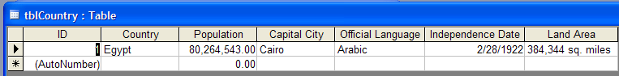

- Save your database.

- Perform finds:
  - With the tblCountry table open, place the insertion point in the Official Language field of the first record.
  - Click Edit →Find. The Find and Replace dialog box appears.
  - Key English or another language into the Find What box.
  - Be sure the Official Language field appears in the Look in box.
  - Click the down arrow on the Match box and choose Any Part of Field from the list.
  - Be sure All appears in the Search box. The Match Case field should not be selected. The Search Fields As Formatted should be selected.
  - Click the Find Next button.
  - Click Find Next again until a message appears telling you that the search item was not found. Click OK.
  - Click Cancel to close the Find and Replace dialog box.

8. Perform sorts:
- Place the insertion point in the Population field in the tblCountry table.
- Click Records → Sort → Sort Ascending. The records appear in lowest to highest order by Population.

- Leave the insertion point in the Population field.
  - Click Records → Sort → Sort Descending. The records appear in highest to lowest order by Population.
  - Perform a sort that will put the records in order from lowest to highest based on Land Area.

- Modify the table (tblCountry):
  - Click View →Design View and add the field: Government Type→Select Text as the Data Type.
  - Switch to Datasheet View and type the information.
  - Click on the New Object: AutoForm button on the toolbar.

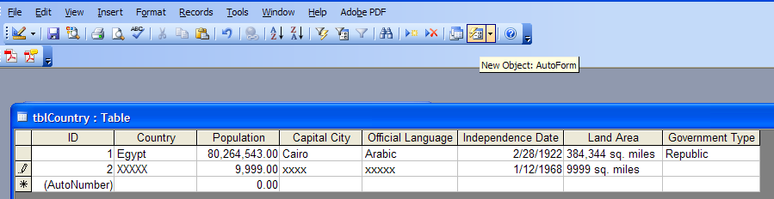

  - AutoForm creates the form and displays it on the screen.
  - Click the arrow to scroll through the records.

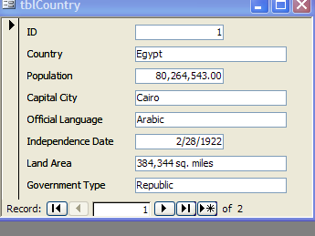

  - Click View →Design View to change font, font size, font color, etc.
  - Click Format→AutoFormat→International→OK.
  - Click View→Form View to see how the form looks.
  - Click Files →Save as frmCountry.

