8_SC_DB_Elements Database
Class Periods: 2
Software: MS Access
Technology TEKS: 7C, 8E, 10B
Subject Area TEKS: 8.4A, 8.9B
Brief Description: Students in eighth grade science classes will
- Create a database of elements
- Perform sorts and finds
- Create a report using the Report Wizard
- Print the report
Define these terms: database, field, record, file, primary key, sort, table, form, and reports
- Seat students in the lab.
- Login to the network.
- Open Microsoft Access software.
- Set up database:
- Click File→New→Blank Database
- Select your H drive and type the name of the database—Elements_db and click Create or press Enter.
- There are seven objects listed on the left side—tables, queries, forms, reports, pages, macros, and modules. Double click Create Table in Design View.
- Type the first field name: Element→Select Text as the Data Type
- Type the second field name: Symbol→Select Text as the Data Type
- Type the third field name: Atomic Number→Select Number as the Data Type
- Type the fourth field name: Atomic Weight→Select Number as the Data Type
- Change the Field Properties at the bottom of the screen to the following: Field Size: Double, Format: Fixed, and Decimal Places: 3
- Type the fifth field name: Classification/Family→Select Text as the Data Type
- Type the sixth field name: Uses →Select Text as the Data Type.
- Place the insertion point in the Element field and click the key icon (picture) on the toolbar. This will make it the primary key.
- Click File→Save. The Save As dialog box opens. Type tblElements_your name as the name of the table and click OK. Do not include periods in your name.
- Click View→Datasheet View to enter the information in the fields. The table looks similar to a spreadsheet in this view.
- Enter the name of the Element in the Element field and strike Tab.
- Enter the Symbol→Atomic Number→Atomic Weight→Classification/Family→Uses. Press Enter
- You have just created a record for one of the elements.
- Enter the remaining records in the table for the other elements.
- Adjust the field widths if necessary to see all of the data.
- Here is a sample of how your table in your database might look:
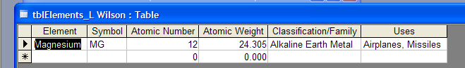
- Save your database.
- Perform finds:
  - With the tblElements table open, place the insertion point in the Classification/Family field of the first record.
  - Click Edit →Find. The Find and Replace dialog box appears.
  - Key ________ into the Find What box. (Teacher will decide. It could be metal, nonmetal, gas, etc.)
  - Be sure the Classification/Family field appears in the Look in box.
  - Click the down arrow on the Match box and choose Any Part of Field from the list.
  - Be sure All appears in the Search box. The Match Case field should not be selected. The Search Fields As Formatted should be selected.
  - Click the Find Next button.
  - Click Find Next again until a message appears telling you that the search item was not found. Click OK.
  - Click Cancel to close the Find and Replace dialog box.
  - How many did you find?

8. Perform sorts:
- Place the insertion point in the Element field in the tblElements table.
- Click Records → Sort → Sort Ascending. The records appear in alphabetical order (A-Z).
  - Place the insertion point in the Atomic Weight field.
  - Click Records → Sort → Sort Descending. The records appear in highest to lowest order by atomic weight.
  - To sort by more than one field, choose Records →Filter, then select Advanced Filter/Sort. The Filter window opens.
  - Clear existing data from the filter window if necessary. Double click Element and Atomic Weight fields. Click the down arrow in the Sort row and choose Ascending for the Element field and Descending for the Atomic Weight field.
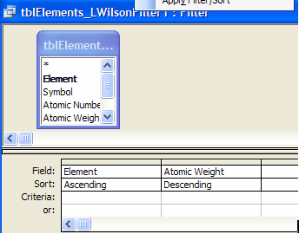

  - Choose Filter→Apply Filter/Sort on the menu bar. Scroll through the table to see that the records have been sorted correctly.
  - 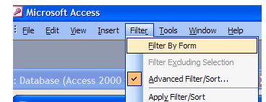
9. Create Form with AutoForm
- Open the tblElements table if necessary.
- Click the New Object: AutoForm button on the toolbar. 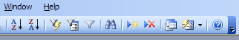
New Object: Auto Form
- If you see a message asking if you want to save and use the table or query to create a new object, click Yes.
- AutoForm creates the form and displays it on the screen.
- Click the arrow to scroll through the records.

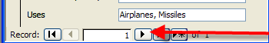

- Click Close on the File menu. A message will appear asking if you want to save changes to the form.
- Click Yes. The Save As dialog box appears.
- Type frmElements_your name in the Form Name box and click OK.
- Close the filter window and the table window if necessary.

10. Create Report with Report Wizard and Print
- Click the Reports button on the Objects bar.

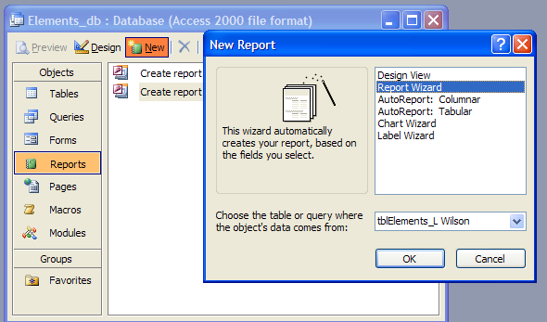

- Click New. The New Report dialog box appears.
- Choose Report Wizard from the list.
- Click the down arrow and choose tblElements from the drop-down list.
- Click OK. The Report Wizard dialog box appears.
- Select Element in the Available Fields list. Click >. The Element field is now listed in the Selected Fields box.
- The Symbol field is now highlighted in the Available Fields list. Click > five times or >> once to move the Atomic Number, Atomic Weight, Classification/Family, and Uses fields to the Selected Fields box.
- Click Next. The Report Wizard now gives you the option to group the report.
- Do not group. Click Next.
- The Report Wizard asks What sort order do you want for your records.
- Choose Atomic Number as the first field to sort by clicking the down arrow next to the number 1 box. Make sure that ascending order is selected.
- Choose Element as the second field to sort in descending order and click Next.
- The Report Wizard asks you to choose a layout and page orientation.
- Choose the Columnar layout. The sample layout is shown in the preview box.
- Choose Landscape as the page orientation, if it is not already selected. Make sure the adjust the field width so all fields fit on a page box is checked.
- Click Next. Choose the Corporate style. The sample style is shown in the preview box.
- Click Next. The final Report Wizard dialog box appears.
- Leave tblElements_your name as the title of the report.
- Make sure the option to preview the report is selected and click Finish.
- The report appears in a window. It should look similar to this.
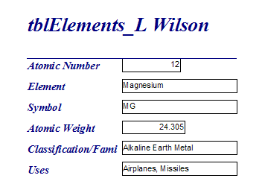
- Make necessary adjustments to the spacing of the report by dragging and/or clicking on the boxes in Design View mode (View→Design View).
- Click the Print button to print the report.
- Choose Close on the File menu. The report will be saved automatically. Save if you have made any changes to the layout of the report.

