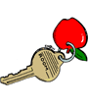
Type Name here
From the Desk of
Type Name here
From the Desk of
Type Name here
From the Desk of
Type Name here
From the Desk of
The KEY to a child’s heart is love!
The KEY to a child’s heart is love!
The KEY to a child’s heart is love!
The KEY to a child’s heart is love!

